**Keith’s Electronics Sales Analysis Project**

The project involves exploratory data analysis to derive critical business insights that can help Keith’s Electronics improve its business. In this analysis, the sales data for 2019(January 2019 to December 2019) has been used to derive the aforementioned business insights.

**Main Libraries Used During this Project**

* Pandas
* Matplotlib
* OS
* Itertools
* Collections

**Data Description**

As mentioned before, the data was for the year 2019 from January to December, and this data was combined and transformed in Excel before the analysis in Python. In Excel, null and duplicate values were removed, and the “Order Date” was converted to DATETIME, whereby the month was retrieved from the “Order Date” into a new column month. In total, the data has seven columns and over 180,000 rows. The following are the questions that guided data analysis.

**Main Questions**

**Question 1: What was the best month for sales? How much was earned in that month?**

This question was solved by first adding the sales column that had the sales of every product and, after that, using the “group by” function to group the sales according to the 12 months.

December was the best month, with Sales of $4,613,443.34, as illustrated by the following graph.

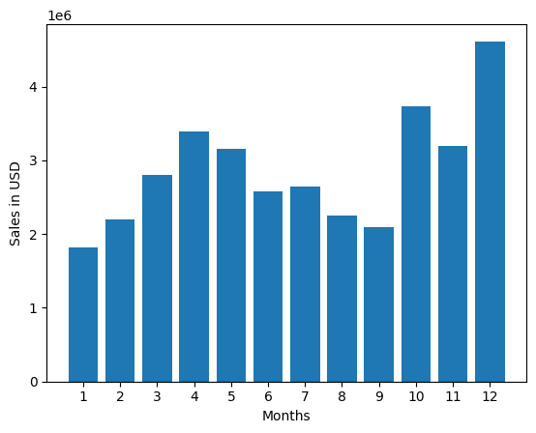

**Question 2: What City had the highest number of Sales?**

To answer this question, the first step was to create a city column, and after that, the (str.strip()) method was used to retrieve the cities from the “Purchase Address” column. It was essential to include the state of each City, considering that some states have similar city names, avoiding similar from being viewed as duplicates.

San Francisco is the City with the most sales: $8,262,203.91, as per the following visualization.

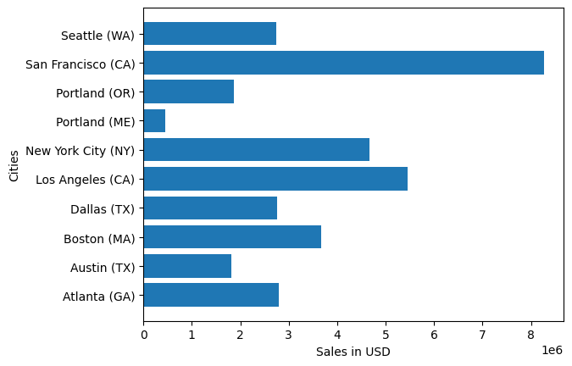

**Question 3: What time should we display advertisements to maximize the likelihood of customers buying a product?**

Using the (str.strip()) method, the time for each order was also retrieved from the “Order Date” column, but the only exception is that the time column was only filled with the hour each order was filled, as it is more viable as compared to using the overall time, i.e., (0830hrs).

Therefore, Before 1100hrs(11 am) and 1900hrs(7 pm) are the best times to advertise as they have the most sales.

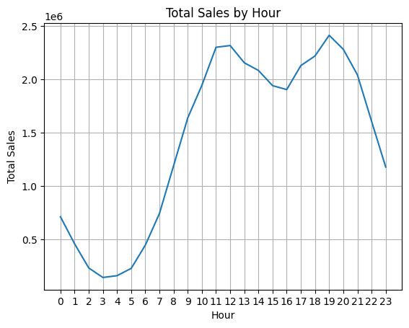

**Question 4: What Products are most often sold together?**

This problem was solved by grouping the “Order ID” while referencing the “Product” Column. These were the primary two columns used in this question, housed by a new data frame. After that, the libraries of itertools and collections helped to remove duplicates from the grouped columns and identified the most common products sold together.

Identifying the products that are most often sold together can be helpful in creating promotions and selling them in bundles to increase sales.

The following were the results.

|  |  |  |
| --- | --- | --- |
| Product 1 | Product 2 | Count |
| iPhone | Lightning Charging Cable | 1005 |
| Google Phone | USB-C Charging Cable | 987 |
| iPhone | Wired Headphones | 447 |
| Google Phone | Wired Headphones | 414 |
| Vareebadd Phone | USB-C Charging Cable | 361 |
| iPhone | Apple Air pods Headphones | 360 |
| Google Phone | Bose SoundSport Headphones | 220 |
| USB-C Charging Cable | Wired Headphones | 160 |
| Vareebadd Phone | Wired Headphones | 143 |
| Lightning Charging Cable | Wired Headphones | 92 |

**Question 5: What product sold the most? Why do you think it sold the most?**

This question was sold using the (group by) method, whereby the “product” column was grouped while referencing the sum of the “Quantity Ordered” column. This returned the results of the product with the most sales. To explain why most products had high numbers, a side-to-side comparison of sales and price was done to establish that the most sold were the cheapest.

Thus, the most sold products are AA Batteries(4-pack) at 27,635 units and AAA Batteries(4-pack) at 31,017 units.

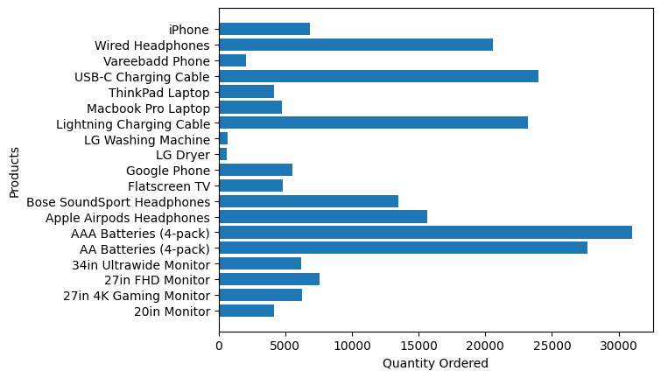

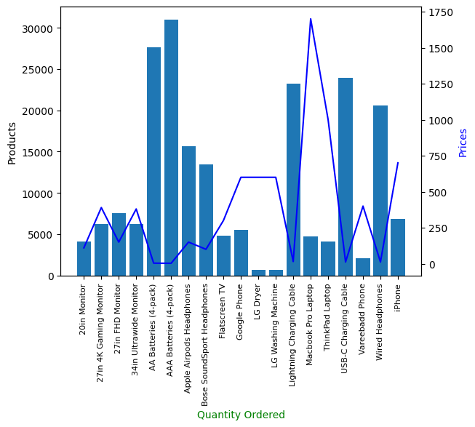

**Reference**

Keith Galli’s YouTube tutorials inspired this project.

- [Keith Galli’s YouTube Channel] (https://www.youtube.com/@KeithGalli)